Vector Field Theory (VFT): A Unified Model of Physics, Philosophy, and Consciousness

1. Introduction
Vector Field Theory (VFT) proposes a comprehensive framework that unifies physical laws, metaphysics, and subjective experience. At its core, VFT recasts fundamental interactions as dynamic vector fields and derives notions of time, mass, force, and consciousness from first principles.
Core Thesis: The universe is a contiguous, static grid of Planck-scale volumes. What we perceive as motion, gravity, and time emerge from varying concentrations of temporal vectors within this grid. Consciousness, logic, morality, and even cosmology arise naturally when this physical model is extended to include the observer’s will and ideological “velocity.”

2. The Meaning of Life & Rationale for VFT
- Definition: "To understand the universe and how it works, to be happy, and to be harmonious."
- Motivation:
  - Cellular and biological sensing is imprecise; complexity (language, science) evolves to improve precision.
  - A complete theory of everything must integrate origin-of-universe physics, consciousness, and subjective value structures.
- Approach:
  - Treat VFT as a transformative text: mind-expanding, radical, and initially disorienting.
  - Embrace paradox: objective truth (gravity analogue) and subjective truth (magnetism analogue) coexist in a unified vector framework.

3. Foundational Thought Experiment & Genesis Translations
VFT reinterprets the opening chapters of Genesis (and by extension, parallel cosmogonic texts) as vector-field dynamics unfolding in discrete Planck-time steps.
Time (t) | VFT Genesis Translation
t = –1 to 0 | Chaos & Observation: "God" (the universal consciousness field) observes an undifferentiated vector field, the chaotic seed of all spacetime.
t = 1 | Light & Bifurcation: The field transitions from instability; "light" emerges. Positive vector additions (matter) and negative additions (antimatter) arise.
t = 2 | Firmament/Spacetime: A dividing fabric—spacetime—separates lower and higher time-phases; each vector pair defines one Planck-time tick.
... | Subsequent Acts continue according to Genesis 1:9–31, mapped to VFT’s sequential vector interactions.
Similar structural reinterpretations apply to Buddhist, Hindu, Taoist cosmogonies.

4. Key Equations & Laws
- Universal Force Equation (applicable to physical and abstract domains):

  - k = resistance (cultural/institutional inertia)
  - σ = strain (policy pressure, idea tension)
  - V = scope (volume, ideological or spatial extent)
- Political Lorentz Analogue:
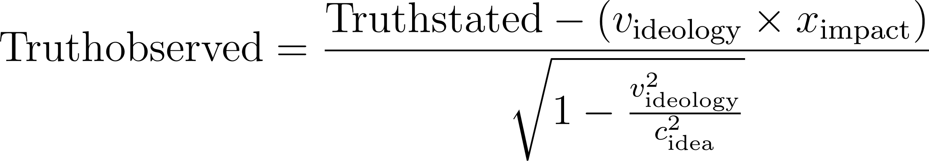
  - Models how policy truth is relativised by ideological velocity, impact timescale, and idea–speed limits.
- Policy Mixing Matrix:
  - A 3×3 unitary matrix for Progressive (p), Centrist (c), Conservative (r) transitions.
  - 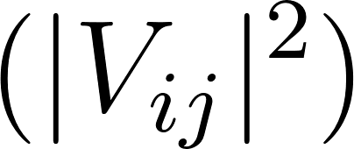 = probability of moving from ideology i to j.

5. VFT vs. Established Theories
Theory | Flaw in Standard Model | VFT Resolution
General Relativity | Spacetime as deformable fabric | Static grid of Planck volumes; gravity arises from time–vector concentration gradients.
Quantum Mechanics | Point particles, probabilistic wavefunction | Fundamental objects = 1D strings; particles = strings locked by temporal vectors; collapse = de‑lock event.
Classical Mechanics | Instantaneous forces, motion through fixed space | Force = propagating compression at c, motion = decompression of time across volumes, causality preserved.
Luminiferous Ether | Static medium with absolute frame | Active, relativistic vector field; no universal frame, explains Michelson–Morley outcome.
String/M-Theory | Abstract extra dimensions, untested | 1D fluid-like strings with fractal time‑phases; harmonics = vibrational modes; extra time‑dimensions parallel.
Higgs Mechanism | Separate mass‑giving field, unexplained mass range | Mass emerges from string stability; Higgs boson = neutral harmonic resonance state.
Absorber Theory | Requires unknown future absorbers | Conservation of opposition: every emission has minimal inverse; no missing absorber needed.
Ptolemaic Model | Earth‑centric cosmology | Each consciousness is the local 'center'; collective will composes shared reality.
Steady‑State Theory | No beginning, constant matter creation | Genesis events recur: continuous cosmic foam with genesis ticks in Planck‑time iterations.
Minkowski Spacetime | Flat 4D manifold without origin or curvature explanation | Fractal Planck pixels; emergent curvature from time–vector compression gradients.

6. Dimensional & Fractal Structure
- 6D Volume: 4 spacetime + 2 opposing time components.
- Fractal Hierarchy: Each x,y,z,t dimension recursively contains its own x,y,z,t, down to the Planck scale.
- Interaction Count: A cubic meter requires a fractal scale (~10ᵖ) for stability, yielding ~120 interaction layers.
- Cosmological Constant (Λ): Residual vacuum energy after fractal‑scale cancellations (≈120 orders); solves the cosmological constant problem.

7. Implications & Applications
- Physics & Cosmology: Provides mechanical origins for gravity, inertia, and quantum phenomena.
- Philosophy & Consciousness: Derives will, logic, morality, and subjective experience from vector dynamics.
- Political Science: Models ideology shifts (mixing matrix), truth perception (Lorentz analogue), and policy force (universal force law).
- Interdisciplinary: Bridges science, theology, and esoterica—offering a map to intuitively "read" the universe’s patterns.

8. Acknowledgements & Closing
With gratitude to: Newton, Einstein, Maxwell, Planck, Mach, Heisenberg, Dirac, Veneziano, Nambu, Nielsen, Susskind, Schwarz, Green, Higgs, Englert, Brout, Guralnik, Hagen, Kibble, Witten.
This foundational pursuit seeks to end the search: VFT unifies physics and metaphysics, revealing both the machinery of the cosmos and the architecture of consciousness.
Next Steps: Review each section’s detailed proofs, expand on missing realizations (from notes), and formalise quantitative examples. VFT remains in progress—every insight and critique brings us closer to a truly unified understanding.

